‘We Might Fly’ pop-up exhibition:
Evaluation Report
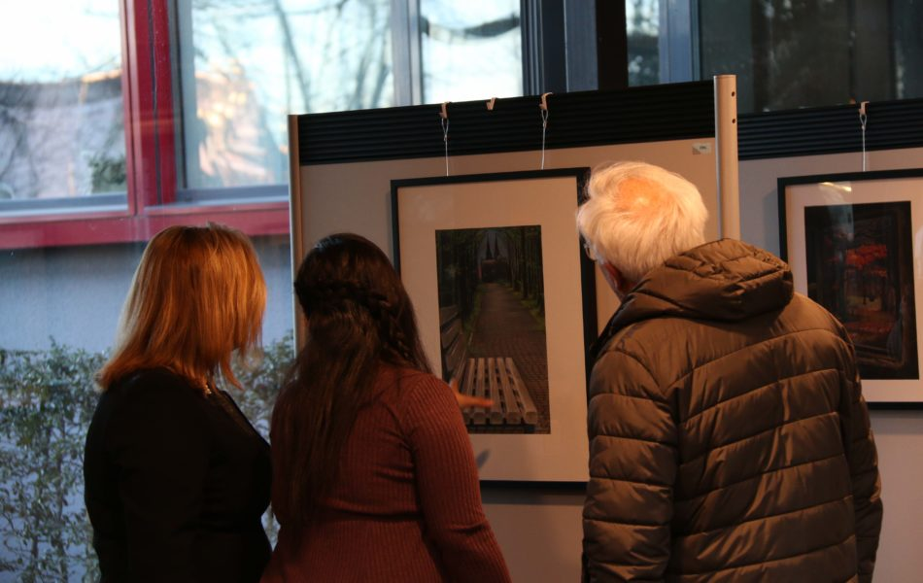

Undertaken for the Wonderland Shire Arts and Culture Unit
by Hannah Bright, April-May 2018
This document is provided by CDN as a sample evaluation report that could be adapted by other councils and agencies to provide evidence-base outcome-focussed evaluation for their exhibitions. Decisions about how much time to invest in data gathering was made with considerations of the real world circumstances of council staff. Thus, the data used in this report was gathered by two staff members who interviewed exhibition audience members in the last hour of the exhibition launch. This makes it a sustainable and manageable amount of work that could be expected as a minimum for every council event. The report produced from this data evidences achievements for the initiative and clear opportunities for improvement, thus indicating the value of council’s investment as well as recommendations for more effective investment in the future.
Report produced by Holly Schauble and Kim Dunphy, July 2018. www.culturaldevelopment.net.au

Evaluation purpose
This report presents the findings of an evaluation of the We Might Fly pop-up art exhibition staged by the People Like Us arts collective at the Small Haven Social Club in Wonderland from 01-07 April 2018. The purpose of evaluation was to determine whether participation in the exhibition increased attendees’ (receptive participants’) appreciation of the diversity of cultural expression, particularly with respect to the cultures of Iran and Syria that were featured in the exhibition. Evaluation data was collected from participants on the opening night of the exhibition on 01 April 2018. The exhibition and its objective of ‘to increase appreciation of diverse forms of cultural expression’ responds directly to the Wonderland Council goal of ‘A creative and connected community that celebrates our multiculturalism” found in the Wonderland Council’s Community Strategic Plan 2018-2024

About We Might Fly
We Might Fly was an exhibition featuring traditional and contemporary visual art forms accompanied by music performance created by Iranian and Syrian refugees as part of Our Culture: Many Different Stories community arts program in Wonderland. The exhibition presented the traditional forms of cultural expression practiced by those communities, both in their home countries prior to their journey to Australia and now that they live in Wonderland.

Evaluation method and design
Evaluation was undertaken through a survey of people attending the opening night exhibition of We Might Fly (survey template attached as Appendix 1). Staff of the gallery administered the survey by approaching attendees at the end of the event and completing a hard copy survey on behalf of the person being surveyed. A decision was made not to interview under 18s, even though they may have been present at the event, because of the need for parental permission for under age respondents.

A post-pre-post design was used, enabling participants to reflect on their appreciation of Iranian and Syrian forms of cultural expression after they had attended the exhibition, and then to reflect back on how much they had appreciated these forms of cultural expression before they attended the event. This design was used to determine how much change in their appreciation occurred as a result of attending the exhibition.

Participants were asked to rate their appreciation of forms of Iranian and Syrian cultural expression after seeing the exhibition. They were asked to choose a number on a scale of 1-10 that best represented their level of appreciation, with 1 being ‘no appreciation’ and 10 being ‘the highest level of appreciation imaginable’. Then, participants were asked to think back to their level of appreciation of forms of Iranian and Syrian cultural expression before they had attended We Might Fly. This was to determine whether the event attracted people who were already appreciative of Iranian and Syrian cultural expression or not.

Thus, the two questions were asked of participants to enable evaluators to determine who was attending the event, in terms of their existing appreciation for Iranian and Syrian cultures; and how much change occurred, both for those who already had low levels of appreciation and those whose appreciation had already been high..

Participants were then asked if they wanted to share anything further about their experience. enabling any other feedback or thought. Lastly, participants were asked some demographic questions: their postcode, to determine whether the event was being attended by people from within the local community and/or from further afield; their age bracket (child, young adult, older adult); their gender identification; and whether they identified as members of the Syrian or Iranian community.

Results

Attendance
We Might Fly exhibition was attended by approximately 500 people over the week. Opening night attracted more than 200 people.

Respondent demographics
20 people (10% of the total number of attendees at opening night) participated in the evaluation on the opening night: 7 (35%) were aged 18-35; 5 (25%) were aged between 35 and 65; 8 (40%) were aged 65 and over. 70% cent of respondents were female, and 30% male. Respondents all came from within the Wonderland Shire, and none indicated that they were members of the Syrian and Iranian community.

Appreciation of diversity of cultural expression

Levels of appreciation before attending
Levels of appreciation of Iranian and Syrian cultural expression that participants reported having before they attended the exhibition ranged from 4 to 10. The lowest scores were 4, reported by one person, and 5, reported by 3 people, making 20% of attendees scoring in the low to medium range of appreciation for these forms of cultural expression. 6 respondents (20%) scored in the mid to high range, from 7-8, while the largest group of attendees were in the very high range, scoring themselves as 9-10, having an existing appreciation of ‘the most imaginable’ or very close to it, as depicted in Figure 1. This indicates that the exhibition was most successful in attracting people who already had significant appreciation of Iranian and Syrian forms of cultural expression; somewhat successful in attracting those who had some appreciation; and not successful at all in attracting people who previously had very little or no appreciation.

Levels of appreciation after attending

After attendance at We Might Fly exhibition, the majority of attendees (13, or 65%) reported increased levels of appreciation for Iranian and Syrian forms of cultural expression. The remaining 35% did not increase their scores, but only because they already rated themselves as having the ‘most imaginable’ appreciation, as depicted in Figure 1. All of that group stayed at the highest level, with no decreases from ‘the most imaginable’ appreciation reported.

The amount of change was most significant for those with previously low levels of appreciation. The attendee with the lowest pre-attendance score of 4 more than doubled his/her appreciation rating to 9. All others who had scored themselves in the relatively low-medium range increased their scores by at least 3 points. Those in the medium-high range mostly increased their scores by 2 or 3, bringing many of them to the ‘most imaginable appreciation’ range. These results indicate that the activity was very successful in supporting attendees to increase their appreciation for Iranian and Syrian forms of cultural expression, especially amongst those whose levels of appreciation had been low before attending We Might Fly.

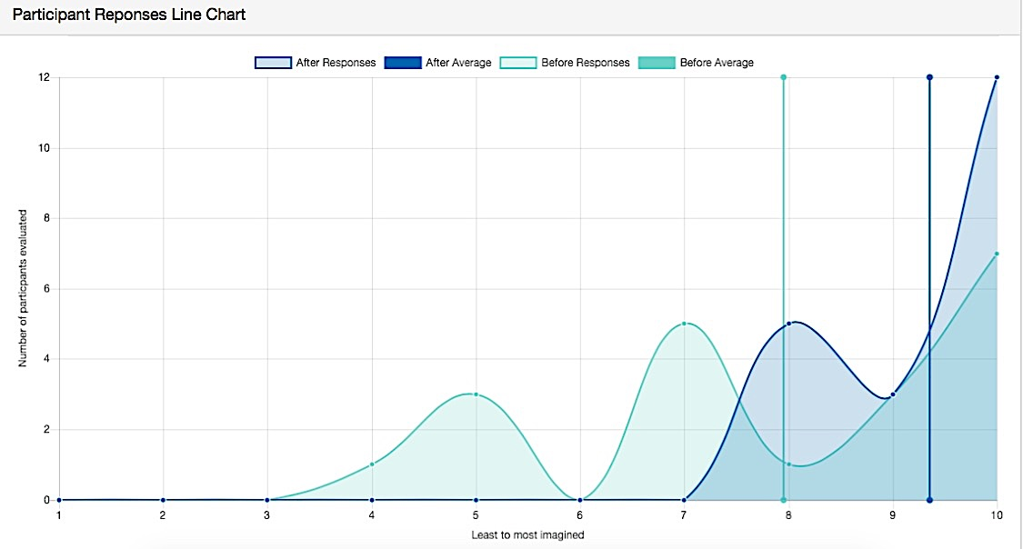

Figure 1: Total rate of change in levels of appreciation of Iranian and Syrian forms of cultural expression before and after We Might Fly attendance.

Qualitative responses

Attendees’ numerical responses were supported by comments that indicated new appreciation for Syrian and Iranian forms of cultural expression. This appreciation seemed to be compounded by the fact that the artworks had been created by people who are now members of the local community:

- “Very moved by Fatima’s exquisite needlework and the stories of her previous life so beautifully depicted. I am an embroiderer myself but I had not known anything about how Syrians embroider until now.”

- ”Loved having direct access to these artists and their work. Beautiful on all counts – thank you for everything.”

- ”I felt privileged to learn so much about the cultures of these people who have been through so much.”

- Great to get an insight into this exhibition as well as local Iranian and Syrian art and culture.”

- “Thank you. It is wonderful to see such beautiful work from our local people.”

Other comments provided information about aspects of the exhibition that contributed to attendees’ appreciation. One respondent whose level of appreciation increased from 5 to 8 enjoyed learning about the artwork in the exhibition but also how the audience received it: ”I appreciated the time and telling of how this exhibition came to be. I loved the movement in the artists’ expression and the intake and interest of the small audience here.”

One respondent’s comments indicated that she anticipated that her level of appreciation would increase upon further visits and reflection: “I think it will take some time to fully appreciate. It’s a bit of a process. I think we’ll be back again and again”.

Conclusion

The large number of people attending the We Might Fly exhibition of Syrian and Iranian visual arts and music (including those attending the launch) demonstrates a desire amongst the Wonderland community to interact with and understand cultures of local Iranian and Syrian community members. The evaluation indicated that adults of all age groups attended the event, with a greater proportion of these being women. It might be that such activities at the gallery attract more women than men generally, indicating an area of possible improvement for the council more broadly and also special exhibitions. Evaluation respondents covered all adult age groups, in roughly similar proportions. This is an encouraging finding for a council wanting to ensure that people of all ages participate in local events.

We Might Fly exhibition resulted as hoped, in increased levels of appreciation of Syrian and Iranian forms of cultural expression. This meant that the exhibition successfully addressed its objective ‘to increase appreciation of diverse forms of cultural expression’ and responded directly to Wonderland Council’s goal of ‘A creative and connected community that celebrates our multiculturalism” found in the Community Strategic Plan 2018-2024.

The greatest impact of the activity was on those who previously had low-moderate levels of appreciation, with significant positive change experienced by all respondents in that category. Those in the medium-high range mostly increased their scores as well, and those already at the highest level stayed there, indicating that they were impacted positively, even though they already had high appreciation.

However, some areas for improvement were also evident. The fact that the event attracted only people who reported existing appreciation of Iranian and Syrian culture indicates that there may be a whole target group of residents who were not reached. This may, self-evidently, be those who did not have existing appreciation who did not make the choice to attend. Strategies to attract such people may need to be carefully considered for similar activities in future.

Other issues arising from the evaluation were that of the 20 people surveyed at the launch, none identified as being a member of the Iranian or Syrian community. This may have been either because there were few of such people in attendance, or because for some reason they were not interviewed. A further possibility, that respondents might have been Iranian or Syrian but chose not to identify as such, seemed unlikely in such a supportive celebratory environment, but it was also a possibility. If the issue was that few people of Iranian and Syrian background attended the exhibition, strategies to improve that situation would need to be implemented for future like events. This may include targeted promotional material, use of community languages in such material, enlistment of ambassadors who could encourage members of their culture to attend, and other pro-active strategies to ensure that members of those cultures felt welcomed and valued as attendees.

If the issue was that members of the Iranian or Syrian community were not interviewed for their feedback at the exhibition, this may indicate the need for staff to be more culturally sensitive in development and implementation of evaluation processes. Perhaps gallery staff members deliberately or unwittingly prioritised speaking to people they already knew or who seemed more familiar to them (presuming they were unlikely to be of Syrian or Iranian heritage themselves). If there were attendees of Iranian and Syrian communities present, perhaps they anticipated language or other barriers in responding and did not offer themselves to respond to the survey. Perhaps the sample of 20 (10% of the attendance that evening) was just too small to cover all categories of attendees.

These findings demonstrate the importance of activities such as We Might Fly for developing appreciation of diverse forms of cultural expression and in this specific case, forms of culture expressed by refugees from Iran and Syria who are now living in Wonderland. Several opportunities to crease access to groups not currently attending are suggested as well as considerations for improvements to the evaluation process.

Future opportunities recommended include a more comprehensive program of cultural activities developed by the local Iranian and Syrian community and People Like Us ,that could contribute to create appreciation of diverse forms of cultural expression in the broader community.

Appendix 1

People Like Us Evaluation Survey
We Might Fly Exhibition

Arts organisation People Like Us have partnered with local Iranian and Syrian communities to present the exhibition, We Might Fly. In doing so, we hope that Wonderland residents had the opportunity to increase their appreciation of forms cultural expression our newest residents practiced in their home countries and now in Australia. In order for us to understand more about the outcomes of our activities, we are undertaking an evaluation survey.

We would like to invite you to participate by answering four questions about your experience today. This will increase our knowledge of the experience of people attending this event. We don’t need any information that will identify you.

We invite you to tell us about your level of appreciation of forms of Iranian and Syrian cultural expression at two points: now that you’ve participated and before you came today.

By appreciation, we mean recognition or understanding of the worth, value or quality of these expressions of Iranian and Syrian cultures. It doesn’t necessarily mean you have to have liked or enjoyed the artwork or the exhibition.

We will use a scale of 1-10, where 1 is none at all and 10 is the most imaginable sense of appreciation you could have

Question 1:

Firstly rate your appreciation of these forms of expression of Iranian and Syrian culture now, having attended today. Choose a number on the scale of 1-10 to represent your appreciation.

1 2 3 4 5 6 7 8 9 10

Question 2:

Now I’d like you to think back to before you came today and rate your appreciation of these forms Iranian and Syrian cultural expression using the same scale of 1-10.

1 2 3 4 5 6 7 8 9 10

Question 3:

Is there anything else you’d like to say about your experience?

Question 4:

A last few questions – what is your postcode? What is your age bracket (young adult 18-35, middle age 35-65; older adult 65 and over ); Your gender identification (Female, Male, other)?; Do you identify as a member of the Syrian or Iranian community?
Thank you very much for your time.

If you’re interested in the evaluation findings from this activity, you can request this information by contacting People Like Us.

