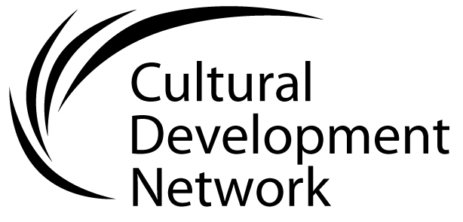 Evaluating the cultural development plan

This schema is offered as a method of determining the effectiveness of a Cultural Development Plan. This evaluation process should occur at different times throughout the life of the plan: from the point at which the plan appears to be finished; as it is being used; and at the end of its life.

When the Cultural Development Plan is just written, its content should be evaluated against the principles in this Framework, as per questions below.
1. | Does it refer to the Council Plan as a guiding document? | Yes/ No
2. | Does it respond to or reference other council strategic documents? | Yes/ No
3. | Is the Plan based on the values of the local community? | Yes/ No
4. | Is it directed towards goals for the whole community as articulated in the Council Plan? | Yes/ No
5. | Is it focussed on achievable, measurable outcomes? | Yes/ No
6. | Is decision making underpinned by theory/ theories of changes? | Yes/ No
7. | Are these theories of change articulated in the Plan? | Yes/ No
8. | Is decision-making in the Plan informed by evidence? | Yes/ No
9. | Is this evidence documented in the Plan? | Yes/ No
10. | Does the Plan state an intention for evaluation to occur during and at the end of the planning cycle? | Yes/ No
11. | Does the Plan indicate that future planning will be responsive to evaluation findings in a learning cycle? | Yes/ No
12. | Has the Plan been approved by council? | Yes/ No
 | Total : Yes No
Scoring your Plan:
Score one point for every Yes, and 0 for every No.
How did you rate?
12: a great score 8-11: you’re heading in the right direction
5-8: you’re getting some things right 4 or less: some new action is required!

