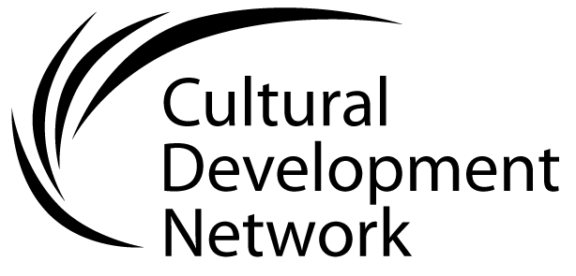 Evaluating the cultural development plan

As the Cultural Development Plan is being used, its effectiveness can be evaluated in terms of its impact on staff members’ function and capacity.

An effective Plan is used as a reference document to guide as to what to do, why and when. It should enable staff to be most efficient and effective and achieve the best outcomes for their community.

Percentage of your team this applies to
Is the Plan used to direct the work of the cultural development team?
Does the Plan assist team members to be effective?
Self-report: This question could be answered by individual team members responding with their perspective about their own performance
Does the Plan assist team members to be effective?
Manager’s report: This question could also be answered by the Managers’ using performance review of officers as data.

